TITLE (Calibri, 16, normal)
First names Name¹, First names Name²
Institution - town, country - complete address (Times New Roman, 10, normal)
Email address of correspondent author (Times New Roman, 10, normal)
Résumé, titre (Calibri, 14, normal, majuscules)
Texte de 200 mots environ (times New Roman, 11, normal)
Mots-clés : en français, (Times New Roman, 11, normal)
Abstract, (title (Calibri, 14, normal, capital)
Introduce English abstract of 200 words approximatively (times New Roman, 11, normal).
Keywords : in english, (Times New Roman, 11, normal)
Introduction (Calibri, 14, normal, majuscules)
Use (Times New Roman, 12, normal). It is possible to use italic to highlight some information but not in bold and underlined.
Please prepare your document using Microsoft Word article must be formatted according to this template. Do not alter the margins and use the predefined styles for title, author(s), affiliation(s), abstract text, keywords…(Times New Roman, 12, normal).
- Title 1 (Calibri, 14, normal)
Use (Times New Roman, 12, normal). It is possible to use italic to highlight some information but not in bold and underlined.
  - Title 2 or Sous-titre (Calibri, 12, normal)
(Idem)
    - TITLE 3 or (1.1.1) (Calibri, 12, normal)
(Idem).
- Tables, diagrammes
They must not be provided in scanned form, but imperatively in the form of a source file (Excel, Openoffice, etc.) in black and white, or in color.
Presentation: table title before the table, (Times New Roman, italic, bold, 11 pts);
TABLEAU 1. Principal properties of selected materials
 | C1 | C3A | C3B | C3C
Sulfidic tailings
porosity | 0.43 | 0.40 | 0.43 | 0.43
NNP (kg CaCO₃/t) | -814.30 | -814.30 | -814.30 | -814.30
AEV (m of water) | 0.80 | 0.80 | 0.80 | 0.80
Note : NNP = Net Neutralization Potential; AEV = Air Entry Value
- Figures, photos, illustrations
They can be given at high resolution (300 DPI minimum, jpeg bitmap, tif, etc..).
Curves must be in black and white or in color and in the form of a source file (Excel, Openoffice, etc.).
All figures, photos, illustrations from other work must be used with the agreement of original author with cited sources.
Présentation : Title, under figure (Times New Roman, italiques, gras, 11 pts).
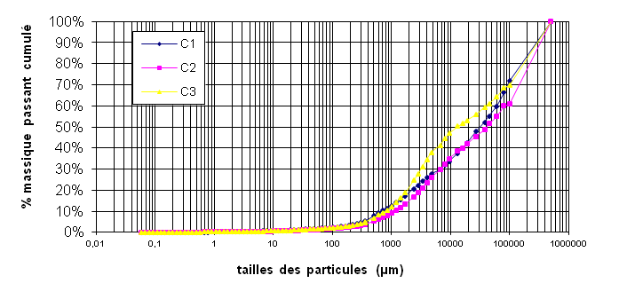
Figure 1. Title

Equations

(1)
Conclusion (Calibri 14, normal, majuscules)
Use (Times New Roman, 12, normal). It is possible to use italic to highlight some information but not in bold and underlined.
References (Calibri 14, normal)
- References are cited on the text by the name of author and year in parenthesis; if publication has two authors, the two names must be cited. More than two authors, only the first name was cited with “et al.” and the year.
- Indicate the existant DOIin the refrences paragraph, on theform: https://doi.org/xxxxxxxxxxxxxx (recommanded in 2017 by CrossRef)
(Times new roman 11) :
book: [cited by : (Bora, 2008)]
Bora O., 2008, Les politiques du risque, Paris, Presses Sciences Politiques, 294 p.
Article: [cited by: (Benbelkacem et al., 2010)]
Benbelkacem H., Bayard R., Abdelhay A., Zhang Y. Et Gourdon R., (2010). Effect of leachate injection modes on municipal solid waste degradation in anaerobic bioreactor. Bioresource Technology, n°101, pp. 5206-5212.
Conference article : [cited by: (Le Hyaric et al., 2009)]
Le Hyaric R., Canler J-P., Barillon B., Naquin P. & Gourdon R. (2009) Anaerobic digestion of screenings from municipal wastewater treatment plants: pilot-scale experimentation. Proceedings of ISWA/APESB 2009 World Congress, International Solid Waste Association, Lisbonne, Portugal, 12-15 Octobre 2009.
Chapter of book : [cited by: (Gourdon, 2006)]
Gourdon R., (2006). Caractérisation et gestion des déchets d’industries agro-alimentaires, pp : 29-46, In Gestion des problèmes environnementaux dans les industries agroalimentaires, 2ème édition 2006, Coordonnateur R. Moletta, Editions Tec&Doc Lavoisier, 720 p.
For other refrences, look at: http://referencesbibliographiques.insa-lyon.fr

